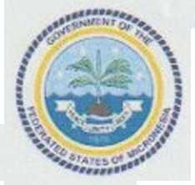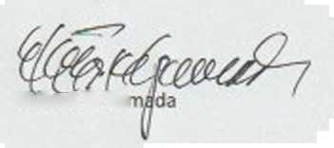

DEPARTMENT OF RESOURCES & DEVELOPMENT

Federated States of Micronesia

P.O. Box PS-12

Palikir, Pohnpei FM 96941

Phone: (691) 320-2620/2646/5133; Fax: (691) 320-5854

E-mail: [fsmrd@fsmrd.fm](mailto:fsmrd@fsmrd.fm)

August 19, 2019

To the Attention of the GAFSP Coordination Unit:

SUBJECT: Submission of the Multi- Country Proposal for the Small Islands Food and Water

Project (SlFWap)

I write to you in reference to the GAFSP Special Call for Fragile and Conflict Affected Countries-Public Sector Window, of 14 March 2019.

I am pleased to submit to your attention the multi-country proposal for the Small Islands Food and Water Project (SlFWap) to be implemented in Kiribati, Republic of the Marshall Islands, Federated States of Micronesia, and Tuvalu.

With this letter I hereby confirm that FSM National Government, Department of Resources and Development:

* Select the International Fund for Agriculture Development (IFAD) as the Investment Supervising Entity and FAO as additional supervising entity for Technical Assistance, and
* Authorizes IFAD to submit the attached proposal on behalf of the Department.

Sincerely,

Hubert K. Yai